Lab # 10

System Programming



Teacher | Bibi Areej Khan
Student Name | Muhammad Ahmad Khan
Registration No | 23JZBCS0238

Department of CS&IT
University of Engineering and Technology Peshawar
(Jalozai Campus)

Objective
The objectives of this lab are:
- To understand the concept of directories in UNIX/Linux systems
- To learn why directories require special handling functions
- To study the use of directory handling functions:
  - opendir()
  - readdir()
  - closedir()
  - rewinddir()
- To understand file metadata using stat() and lstat()
- To study important fields of struct stat
- To implement a simplified version of the ls -l command
- To display:
  - File names
  - File permissions
  - File type
  - File size
  - Last modification time

Theory
In UNIX/Linux operating systems, everything is treated as a file, including directories. A directory is a special type of file that stores information about other files and directories.
Unlike regular files, directories cannot be accessed properly using normal file system calls such as:
- open()
- read()
- write()
- close()
Instead, special directory handling functions are provided in the <dirent.h> library.
These functions allow programs to:
- Open directories
- Read directory entries
- Traverse directory contents
- Close directory streams safely
File-related information such as permissions, ownership, timestamps, and size can be obtained using:
- stat()
- lstat()
These functions store file information inside a structure called struct stat.
The Linux command ls -l displays detailed file information such as:
- File type
- Permissions
- File size
- Modification date and time
- File name
In this lab, we implement a simplified version of the ls -l command using C programming.

Directory Access Functions

opendir()
Opens a directory stream.

Syntax
DIR *opendir(const char *dirname);

Returns
- Pointer to DIR
- NULL if unsuccessful

readdir()
Reads directory entries one by one.

Syntax
struct dirent *readdir(DIR *dirp);

Returns
- Pointer to struct dirent
- NULL when no entries remain

closedir()
Closes an opened directory stream.

Syntax
int closedir(DIR *dirp);

Returns
- 0 on success
- -1 on failure

rewinddir()
Resets the directory stream to the beginning.

Syntax
void rewinddir(DIR *dirp);

File Status Functions

stat()
Returns information about a file.

lstat()
Returns information about symbolic links.
Both functions use:
struct stat
to store metadata.

Important Fields of struct stat
Field | Description
st_mode | File type and permissions
st_size | File size
st_uid | User ID
st_gid | Group ID
st_nlink | Number of hard links
st_atime | Last access time
st_mtime | Last modification time
st_ctime | Last status change time

Lab Tasks

Task 01 — Read Directory Contents

Problem Statement
Write a C program to:
- Open a directory using opendir()
- Read files using readdir()
- Display only file names

Code
#include <stdio.h>
#include <dirent.h>

int main() {

DIR *dir;
struct dirent *entry;

dir = opendir(".");

if (dir == NULL) {
perror("opendir");
return 1;
}

printf("Files in current directory:\n\n");

while ((entry = readdir(dir)) != NULL) {

printf("%s\n", entry->d_name);
}

closedir(dir);

return 0;
}

Compilation Command
gcc task1.c -o task1

Execution Command
./task1

Output
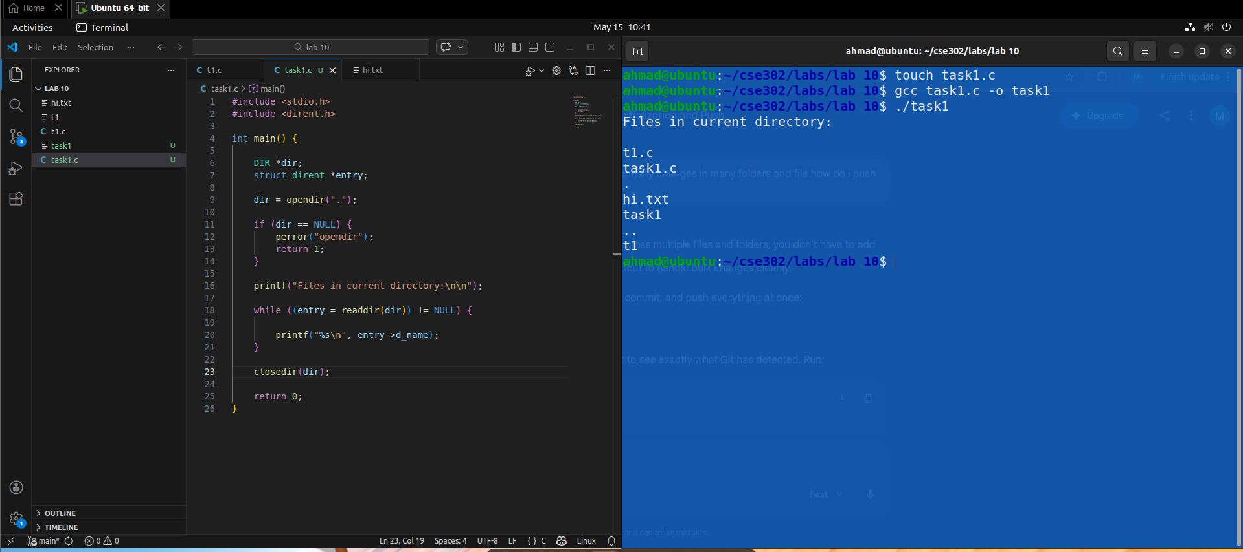

Explanation
- opendir(".") opens the current directory.
- readdir() reads directory entries one by one.
- entry->d_name stores the file name.
- closedir() closes the directory stream.

Task 02 — Display File Information

Problem Statement
Modify the previous program to:
- Use stat()
- Display:
  - File size
  - Last modification time

Code
#include <stdio.h>
#include <dirent.h>
#include <sys/stat.h>
#include <time.h>

int main() {

DIR *dir;
struct dirent *entry;
struct stat fileStat;

dir = opendir(".");

if (dir == NULL) {
perror("opendir");
return 1;
}

printf("File Information:\n\n");

while ((entry = readdir(dir)) != NULL) {

if (stat(entry->d_name, &fileStat) == -1) {
perror("stat");
continue;
}

printf("File Name: %s\n", entry->d_name);
printf("File Size: %ld bytes\n", fileStat.st_size);
printf("Last Modified: %s\n", ctime(&fileStat.st_mtime));
}

closedir(dir);

return 0;
}

Compilation Command
gcc task2.c -o task2

Execution Command
./task2

Output
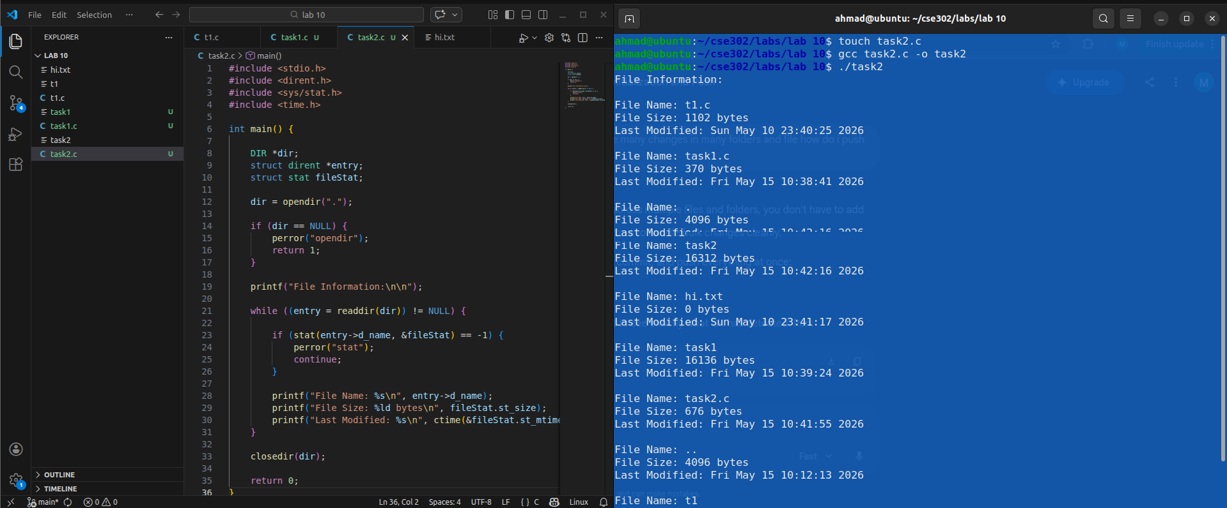

Explanation
- stat() retrieves metadata of a file.
- st_size stores file size.
- st_mtime stores last modification time.
- ctime() converts time into readable format.

Task 03 — Implement ls -l Command

Problem Statement
Extend the program to:
- Display file permissions in rwx format
- Show file type
- Match output similar to ls -l

Code
#include <stdio.h>
#include <dirent.h>
#include <sys/stat.h>
#include <time.h>

void print_permissions(mode_t mode) {

printf((S_ISDIR(mode)) ? "d" : "-");

printf((mode & S_IRUSR) ? "r" : "-");
printf((mode & S_IWUSR) ? "w" : "-");
printf((mode & S_IXUSR) ? "x" : "-");

printf((mode & S_IRGRP) ? "r" : "-");
printf((mode & S_IWGRP) ? "w" : "-");
printf((mode & S_IXGRP) ? "x" : "-");

printf((mode & S_IROTH) ? "r" : "-");
printf((mode & S_IWOTH) ? "w" : "-");
printf((mode & S_IXOTH) ? "x" : "-");
}

int main() {

DIR *dir;
struct dirent *entry;
struct stat fileStat;

dir = opendir(".");

if (dir == NULL) {
perror("opendir");
return 1;
}

printf("Directory Listing:\n\n");

while ((entry = readdir(dir)) != NULL) {

if (stat(entry->d_name, &fileStat) == -1) {
perror("stat");
continue;
}

print_permissions(fileStat.st_mode);

printf(" %ld", fileStat.st_size);

printf(" %s", ctime(&fileStat.st_mtime));

printf(" %s\n", entry->d_name);
}

closedir(dir);

return 0;
}

Compilation Command
gcc task3.c -o task3

Execution Command
./task3

Output
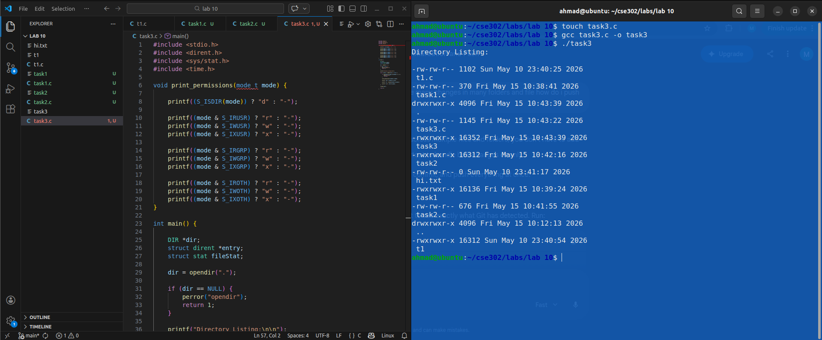

Explanation

print_permissions()
This function converts permission bits into human-readable format:
rwxr-xr-x
using:
- S_IRUSR
- S_IWUSR
- S_IXUSR
and similar macros.

S_ISDIR(mode)
Checks whether the entry is a directory.

Output Similar to ls -l
The program displays:
- File type
- Permissions
- File size
- Modification time
- File name
similar to the Linux command:
ls -l

Conclusion
In this lab, we studied directory handling in UNIX/Linux systems using C programming. We learned how to use:
- opendir()
- readdir()
- closedir()
- stat()
to access directory contents and retrieve file metadata.
We also explored the struct stat structure and implemented a simplified version of the ls -l command that displays:
- File permissions
- File type
- File size
- Modification time
- File names
This lab provided practical understanding of low-level file system operations and directory management in Linux.

